Final Exam

Course Code: HRD6201

Course Title: Organization and architecture of computing systems

Duration: 1 Hour
Student Name: Kem Danil Student ID: 39292
INSTRUCTIONS:
- Open Book / Open Tools: You are permitted to use online resources and AI tools.
- Show Your Work: Because tools are allowed, no marks will be awarded for the final answer alone. You must explicitly show the derivation steps, Truth Table construction, and logic simplification process to prove your understanding.
- Submission: Upload your answers as a PDF or Word file.

Question 1: Boolean Algebra & Logic Simplification
Consider the following Boolean expression for output Y:
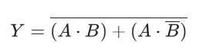
1.1 Simplify this expression step-by-step using Boolean Algebra laws (e.g., DeMorgan’s Laws, Distributive Law). You must show every step of your derivation.
1.2 Based on your simplified result, identify the specific logic gate that corresponds to Y.
1.3 Draw the logic symbol for this final simplified gate.

Question 2: Logic Design & Verbal Translation
2.a: Circuit Identification: Consider the Boolean function F given by the sum-of-products expression below:
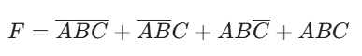
i. Simplify the expression F to its shortest form using Boolean algebra.
ii. Identify the single logic gate that can compute this entire expression.
iii. Draw the standard symbol for this gate and provide its complete Truth Table.
2.b: Verbal Description to Logic
A digital controller for a "Smart Fan" system has three inputs: M (Master Switch), T (Temperature Sensor), and H (Humidity Sensor), and one output F (Fan).
Logic Description:
"If the Master Switch (M) is ON (logic 1), the Fan (F) must be ON regardless of the sensors. If the Master Switch is OFF (logic 0), the Fan should only turn ON if BOTH the Temperature (T) and Humidity (H) are High (logic 1)."
i. Construct the Truth Table for this system listing all combinations of inputs M, T, H and the output F.
ii. From the Truth Table, derive the unsimplified Boolean expression for F.
iii. Simplify the expression to its most efficient form.
- Draw the logic symbol for this final simplified gate.

End of Exam

QUESTION 1
Boolean Algebra & Logic Simplification
1.1 Simplify this expression step-by-step using Boolean Algebra laws (e.g., DeMorgan’s Laws, Distributive Law). You must show every step of your derivation.
Given expression: Y = (A·B) + (A·B̄)
Step 1
Factor out the common variable I can see that variable A appears in both terms. Using the Distributive Law, I factor out A:
(A·B) + (A·B̄) = A·(B + B̄)
Step 2
Apply the Inverse Law Now I simplify the expression inside the brackets. According to the Inverse Law (Complement Law), any variable OR its complement equals 1:
B + B̄ = 1
So I get: A·(B + B̄) = A·1
Step 3
Apply the Identity Law Any variable AND with 1 equals the variable itself:
A·1 = A
Step 4
Apply the final inversion The original expression had a NOT operation over everything. Now I apply it to the simplified result:
Y = Ā
Final simplified form: Y = Ā

1.2 Based on your simplified result, identify the specific logic gate that corresponds to Y.
From the simplified Boolean expression Y = Ā, it is clear that the output Y is the logical complement of the input A. This mathematical relationship defines the operation of a NOT gate (commonly referred to as an Inverter).
Key reasons for this identification:
The circuit has only one active input (A) after simplification.
The output state is always the opposite of the input state.
In Boolean logic, the overline symbol (Ā) specifically represents the NOT operation.
Therefore, the entire original expression can be replaced by a single NOT gate.
Functional characteristics:
Input: A (single input variable)
Output: Y = Ā (complement of A)
Operation: Logical negation/inversion
The NOT gate is one of the three basic logic gates (along with AND and OR) and is essential in digital circuit design. It inverts the binary state of the input signal, converting 0 to 1 and 1 to 0.

1.3 Draw the logic symbol for this final simplified gate.

The simplified expression Y = Ā corresponds to a standard NOT gate. Below is the logic symbol representing the final simplified circuit:
Logic Symbol:
The NOT gate symbol consists of a triangle pointing right with a small circle (inversion bubble) at the output terminal.
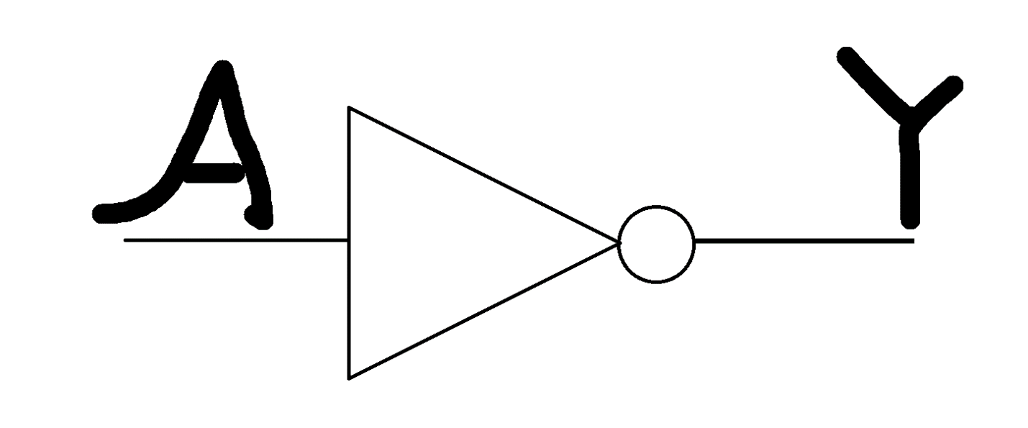
The circle at the output indicates logical inversion.
Truth Table:
The following truth table demonstrates the behavior of the NOT gate:
A | Y = Ā
0 | 1
1 | 0
Explanation: When input A is 0, the output Y is 1. When input A is 1, the output Y is 0. The output is always the inverse of the input.
This truth table confirms that the simplified expression correctly represents a NOT gate operation.

QUESTION 2

Logic Design & Verbal Translation
2.a: Circuit Identification: Consider the Boolean function F given by the sum-of-products expression below:

- Simplify the expression F to its shortest form using Boolean algebra.
Given function: F = ĀBC + ĀB̄C + AB̄C + ABC
Step 1
Grouping I will group the first two terms and the last two terms to factor out common variables:
F = (ĀBC + ĀB̄C) + (ABC̄ + ABC)
Step 2
Factoring From the first group, I factor out ĀC: ĀBC + ĀB̄C = ĀC(B + B̄)
From the second group, I factor out AB: ABC̄ + ABC = AB(C̄ + C)
So now: F = ĀC(B + B̄) + AB(C̄ + C)
Step 3
Applying Inverse Law Since (B + B̄) = 1 and (C̄ + C) = 1, I can simplify:
F = ĀC(1) + AB(1)
Step 4
Apply Identity Law Using the Identity Law (X · 1 = X):
F = ĀC + AB
Final simplified form: F = ĀC + AB

- Identify the single logic gate that can compute this entire expression.
The simplified expression F = ĀC + AB matches the standard characteristic equation of a 2-to-1 Multiplexer (MUX).
Reasoning:
A 2-to-1 MUX works by selecting one of two inputs based on a selector bit. Its general formula is Y = S̄I0 + SI1. By comparing this to my result:
A is the Select line (S)
C is the input for Data Line 0 (I0)
B is the input for Data Line 1 (I1)
Functional Logic:
When A = 0, the term AB becomes 0, and the output F = C.
When A = 1, the term ĀC becomes 0, and the output F = B.
Therefore, a single 2-to-1 Multiplexer can compute this entire expression by routing either signal B or C to the output depending on the state of A.

- Draw the standard symbol for this gate and provide its complete Truth Table.

To represent the simplified function F = ĀC + AB, I have constructed the truth table below. It demonstrates that the circuit selects input C when A = 0 and input B when A = 1.
Truth Table for 2-to-1 Multiplexer:

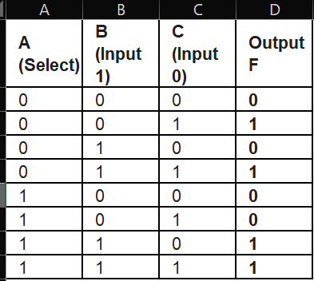
Logic Symbol: The standard symbol for this gate is a trapezoid, representing a Multiplexer.

2.b: Verbal Description to Logic
A digital controller for a "Smart Fan" system has three inputs: M (Master Switch), T (Temperature Sensor), and H (Humidity Sensor), and one output F (Fan).
Logic Description:
"If the Master Switch (M) is ON (logic 1), the Fan (F) must be ON regardless of the sensors. If the Master Switch is OFF (logic 0), the Fan should only turn ON if BOTH the Temperature (T) and Humidity (H) are High (logic 1)."
- Construct the Truth Table for this system listing all combinations of inputs M, T, H and the output F.

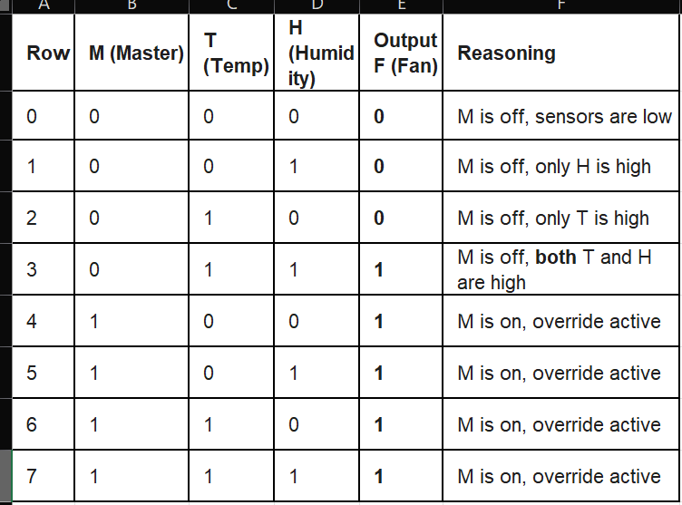
- From the Truth Table, derive the unsimplified Boolean expression for F.
To derive the unsimplified expression, I write the sum of minterms where the output F = 1 (Rows 3, 4, 5, 6, 7):

F = (M̄ · T · H) + (M · T̄ · H̄) + (M · T̄ · H) + (M · T · H̄) + (M · T · H)
- Simplify the expression to its most efficient form.
I will simplify the expression step by step:

Step 1:
Group all terms containing M

F = M̄TH + M(T̄H̄ + T̄H + TH̄ + TH)

Step 2:
Simplify the M group

The expression inside the parentheses (T̄H̄ + T̄H + TH̄ + TH) covers all possible combinations of T and H, which equals 1.

Therefore: M(T̄H̄ + T̄H + TH̄ + TH) = M(1) = M

Step 3:
Substitute back

F = M + M̄TH

Step 4:
Apply the Redundancy Law

The Redundancy Law states: A + ĀB = A + B

Taking A = M and B = TH:

F = M + TH

Final simplified form: F = M + TH

- Draw the logic symbol for this final simplified gate.

